**ASSIGNMENT 1**

**MERN STACK 2**



**NAME: SAIM BIN ZAHID**

**REF NO: 22556**

**17-09-2022**

1. **Write a JavaScript function to get the last element of an array. Passing a parameter 'n' will return the last 'n' elements of the array.**

**CODE:**

var last = function(array, n) {

if (array == null)

return void 0;

if (n == null) { return array[array.length - 1]; }

return array.slice(Math.max(array.length - n, 0));

};

console.log(last([1, -8, 7, 9]));

console.log(last([1, -8, 7, 9],3));

console.log(last([1, -8, 7, 9],6));

**OUTPUT:**

1. **Write a simple JavaScript program to join all elements of the following array into a string.**

**CODE:**

myColor = ["I", "Have", "A", "Car"];

console.log(myColor.toString());

console.log(myColor.join());

console.log(myColor.join('+'));

**OUTPUT:**

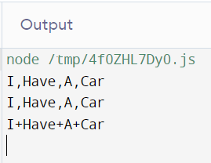

1. **Write a simple JavaScript program to join all elements of the following array into a string.**

**CODE:**

const num=window.prompt();

const str = num.toString();

const result = [str[0]];

for(let x=1; x<str.length; x++) {

if((str[x-1]%2 === 0)&&(str[x]%2 === 0)) {

result.push('-', str[x]); }

else {

result.push(str[x]);

}} console.log(result.join(''));

**OUTPUT:**



1. **Write a JavaScript program to find the most frequent item of an array**

**CODE:**

var arr1=[3, 'b', 'c', 'a', 2, 3, 'a', 3, 'l', 2, 4, 9, 3];

var mf = 1;

var m = 0;

var item;

for (var i=0; i<arr1.length; i++)

{ for (var j=i; j<arr1.length; j++)

{ if (arr1[i] == arr1[j])

m++;

if (mf<m) { mf=m;

item = arr1[i]; }}

m=0; }

console.log(item+" ( " +mf +" times ) ") ;**OUTPUT:**

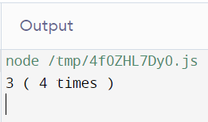

1. **Write a JavaScript program to compute the sum and product of an array of integers.**

**CODE:**

var array = [5, 8, 7, 2, 3, 1],

sum = 0,

product = 1,

i;

for (i = 0; i < array.length; i += 1)

{

sum += array[i];

product *= array[i];

}

console.log('Sum : '+sum + ' \nProduct : ' +product);

**OUTPUT:**

1. **Write a JavaScript function to find the difference of two arrays.**

**CODE:**

function differenceOf2Arrays (array1, array2) {

var temp = [];

array1 = array1.toString().split(',').map(Number);

array2 = array2.toString().split(',').map(Number);

for (var i in array1) { if(array2.indexOf(array1[i]) === -1) { temp.push(array1[i]); }

for(i in array2) { if(array1.indexOf(array2[i]) === -1) temp.push(array2[i]); }

return temp.sort((a,b) => a-b); }

console.log(differenceOf2Arrays([1, 2, 3], [100, 2, 1, 10]));

console.log(differenceOf2Arrays([1, 2, 3, 4, 5], [1, [2], [3, [[4]]],[5,6]]));

**OUTPUT:**

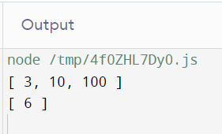

1. **Write a JavaScript program to combine the numbers of a given array into an array containing all combinations.**

**CODE:**

const powerset = arr => arr.reduce((a, v) => a.concat(a.map(r => [v].concat(r))), [[]]);

console.log(powerset([1, 2]));

console.log(powerset([1, 2, 3]));

console.log(powerset([1, 2, 3, 4]));

**OUTPUT:**

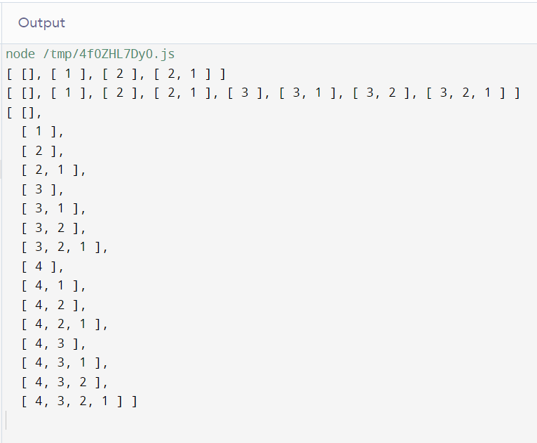

1. **Write a JavaScript program to get a random element from an array (using Math functions)**

**CODE:**

function random_item(items)

{ return items[Math.floor(Math.random()*items.length)]; }

var items = [5, 7, 2, 9,-1];

console.log(random_item(items));

**OUTPUT:**

1. **Write a JavaScript program to check whether a given array of integers is sorted in ascending order**

**CODE:**

function arraySortedOrNot(arr, n)

{ if (n == 1 || n == 0)

return 1;

if (arr[n - 1] < arr[n - 2])

return 0;

return arraySortedOrNot(arr, n - 1); }

let arr = [ 1, 2, 3, 4, 8, 9 ];

let n = arr.length;

if (arraySortedOrNot(arr, n) != 0) { document.write("Yes");}

else { document.write("No"); }

**OUTPUT:**

1. **Write a JavaScript program to replace the first digit in a string (should contain at least one digit) with a $ character**

**CODE:**

function replace_first_digit(input_str) {

return input_str.replace(/[0-9]/, '$'); }

console.log(replace_first_digit("sa1m"));

**OUTPUT:**

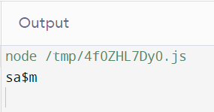

1. **CODE:**

**OUTPUT:**

1. Print each vowel of String in order on a new line, then print each consonant in order on a new line

**CODE:**

const vowelsAndconsonants = str => {

const vowels=['a','e','i','o','u'];

const str_array=str.replace(/[^a-zA-Z]/g, '').split('');

const vowels_final=str_array.filter( a => vowels.includes(a.toLowerCase()));

const consonant_final=str_array.filter( a => !vowels.includes(a.toLowerCase()));

return vowels_final.join('') + '\n' + consonant_final.join('');

}

console.log(vowelsAndconsonants('testing my vowels'))

**OUTPUT:**

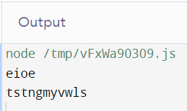

1. Print the second largest value from Array.

**CODE:**

function print2largest(arr, arr_size) {

let i, first, second;

if (arr_size < 2) { document.write(" Invalid Input ");

return; }

arr.sort();

for (i = arr_size - 2; i >= 0; i--) {

if (arr[i] != arr[arr_size - 1]) {

document.write("The second largest element is " + arr[i]);

return; }}

document.write("There is no second largest element<br>"); }

let arr= [ 2, 40, 1, 0, 68, 18 ];

let n = arr.length;

print2largest(arr, n);

**OUTPUT:**

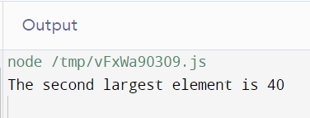

1. **Write printGrade(score) function to print the following output: i) If 35 > score <= 40, then grade = A ii) If 30 > score <= 35, then grade = B iii) If 25 > score <= 30, then grade = C iv) If 20 > score <= 25, then grade = E v) If 0 >= score <= 20, then grade = F (Note: Use Conditional Statement: If-else)**

**CODE:**

let marks=[25, 65, 46, 98, 78, 65];

let max_marks = marks.length * 100;

let total = 0;

let grade = 'F';

for (let i = 0; i < marks.length; i++) { total += marks[i]; }

let percentage = ((total) / max_marks) * 100;

if (percentage >= 90) {grade = 'A';}

else { if (percentage >= 80 && percentage <= 89) {grade = 'B';}

else { if ( percentage >= 60 && percentage <= 79) { grade = 'C'; }

else { if (percentage >= 33 && percentage <= 59) {grade = 'D';}

else {grade = 'F';}

}}}

document.write(grade);

**OUTPUT:**

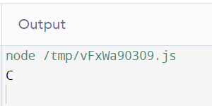

1. Write getLetter (string) function to print the following output: i) If the first character in string is in set {a, e, i, o, u} then return 1 ii) If the first character in string is in set {b, c, d, f, g} then return 2 iii) If the first character in string is in set {h, j, k, l, m} then return 3 iv) If the first character in string is in set {v, w, x, y, z} then return 4 (Note: Use Conditional Statement: Switch)

**CODE:**

function getLetter(s) {

let letter;

switch (s[0]) {

case ('a' || 'e' || 'o' || 'i' || 'u'):

letter = 1;

break;

case ('b' || 'c' || 'd' || 'f' || 'g'):

letter = 2;

break;

case ('h' || 'j' || 'k' || 'l' || 'm'):

letter = 3;

break;

case ('v' || 'w' || 'x' || 'y' || 'z'):

letter = 4;

}

return letter;

1. Write a function that has one array as a parameter. It must iterate through an array and perform the following action on each element i) If the element is even, multiply by 2 ii) If the element is odd, multiply by 3 (Note: Function must return modify array)

**CODE:**

function modifyArray(nums) {

return (nums || []).map(num => num * (num % 2 === 0 ? 2 : 3));

}

**OUTPUT:**

1. Create a simple calculator

**CODE:**

const operator = prompt('Enter operator ( either +, -, * or / ): ');

const number1 = parseFloat(prompt('Enter first number: '));

const number2 = parseFloat(prompt('Enter second number: '));

let result;

if (operator == '+') {result = number1 + number2;}

else if (operator == '-') {result = number1 - number2;}

else if (operator == '*') {result = number1 * number2;}

else {result = number1 / number2;}

// display the result

console.log(`${number1} ${operator} ${number2} = ${result}`);

**OUTPUT:**

1. Print the maximum and minimum values from an array

**CODE**

var numbers = [1, 5, 2, -7, 13, 4];

var maxValue = Math.max(...numbers);

console.log(maxValue); // Prints: 13

var minValue = Math.min(...numbers);

console.log(minValue); // Prints: -7

**OUTPUT**

